PART l:

1. Explain what happens for the child process if you kill the parent process and keep the child process alive (in the screenshot, please include the status of the child process and answer the question based on that status)

The child process will be considered as an “orphan” and wil be adopted by systemd.

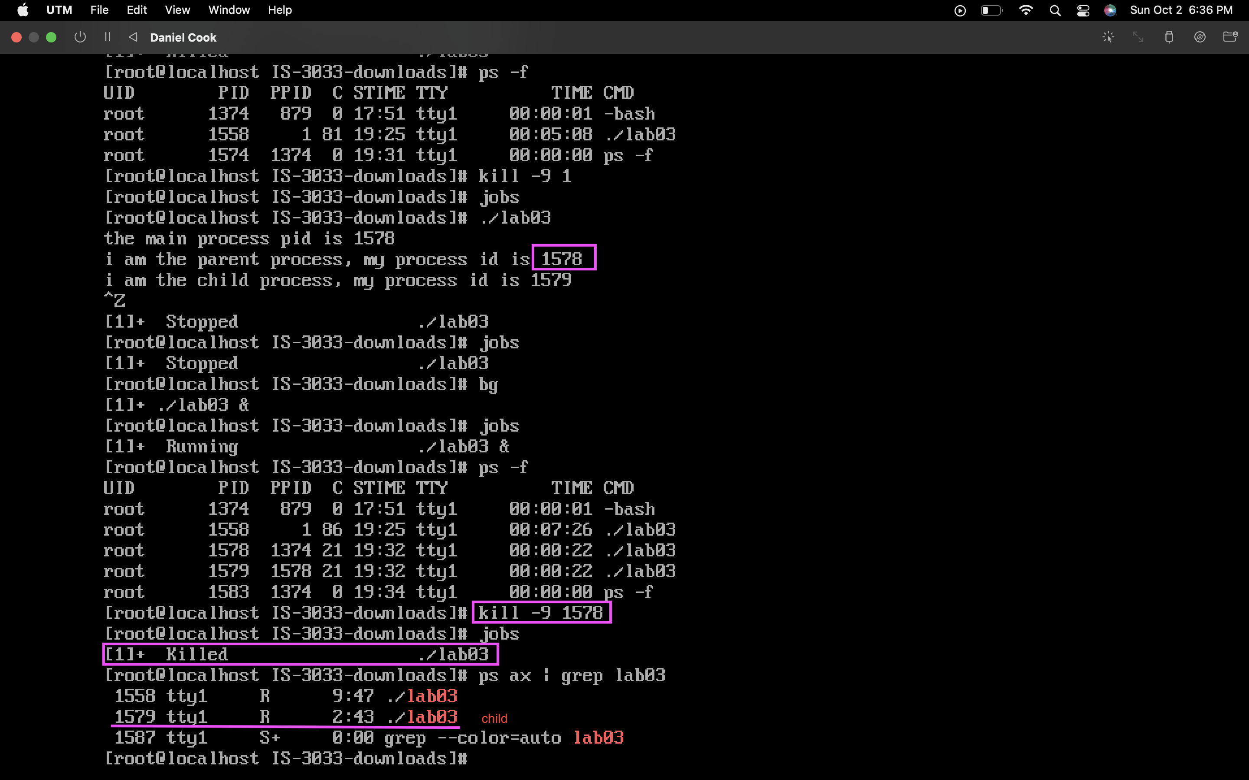

1. Run the executable again, then explain what happens if you kill the child process and keep the parent process alive (in the screenshot, include the status of the child process and answer the question based on that status).

A child process will become a “zombie” if the parent process doesn’t recycle the “body”.

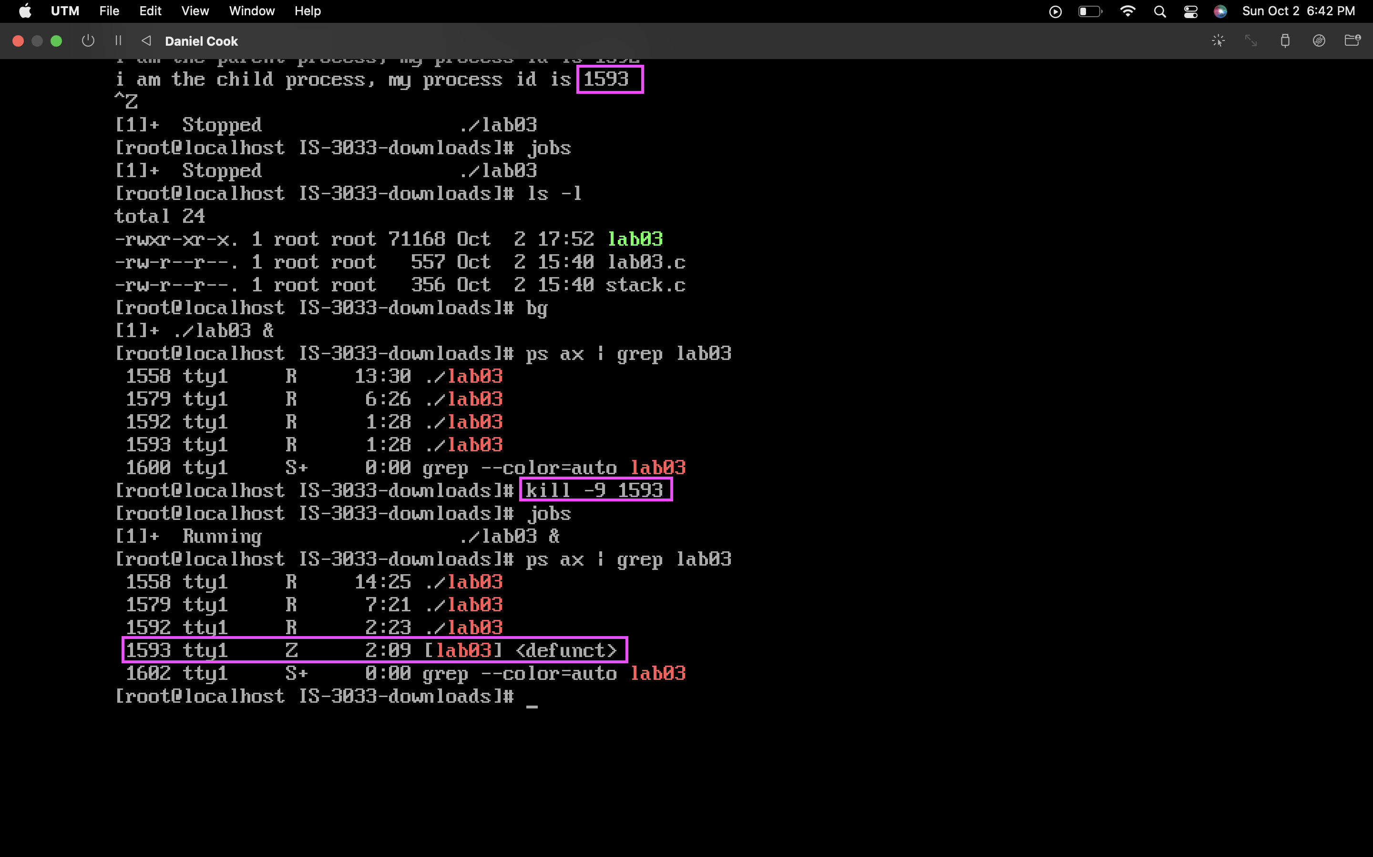

1. Please explain the output data for the parent and child process column by column.

It shows that the child status is a zombie, having 0 virtual memory size and 0 resident set size. It shows that it's under the root user. %Mem it's the percentage use of total physical memory by the process. TTY is the “Teletypewriter”.

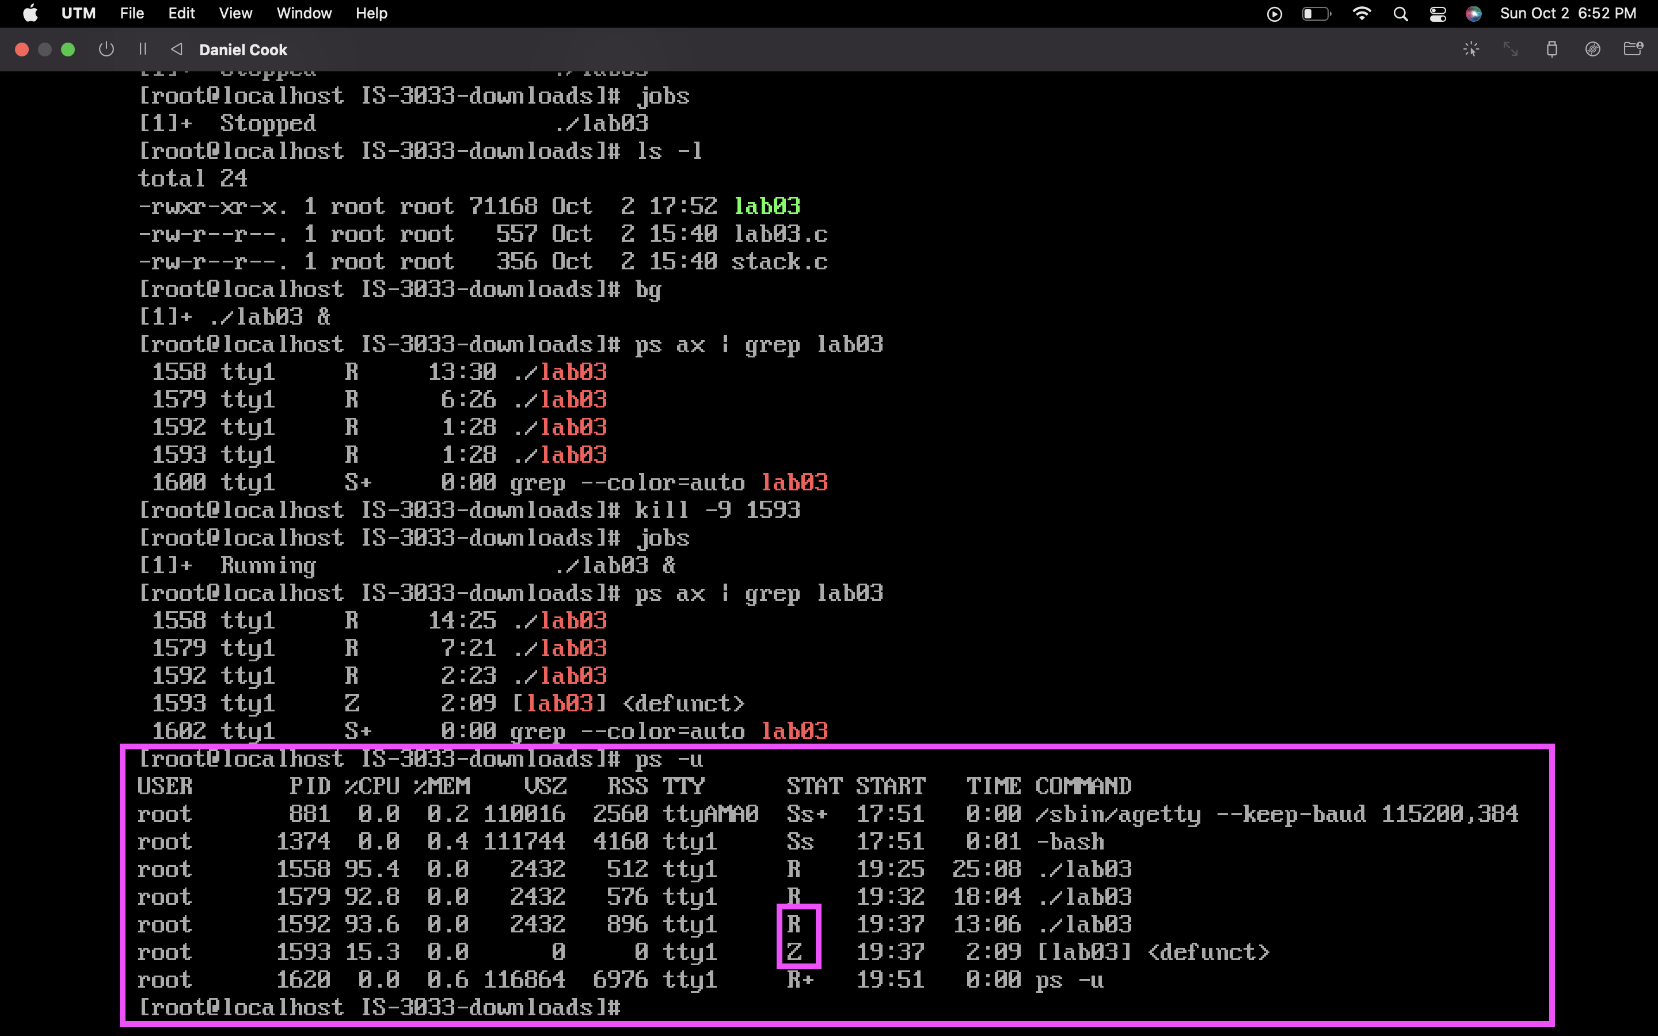

PART III:

|  |  |  |  |  |
| --- | --- | --- | --- | --- |
| Process | Arrival | Burst | Wait | Turnaround |
| P1 | 0 | 3 | 0 | 3 |
| P2 | 0 | 11 | 3 | 14 |
| P3 | 0 | 16 | 14 | 30 |
| P4 | 0 | 6 | 30 | 36 |
| P5 | 0 | 2 | 36 | 38 |

1. In what order do the processes run? P1>P2>P3>P4>P5

2. What is the total turnaround time required for all processes (it is incorrect if you simply add the numbers above together)? 3+14+30+36+38= 121 total turnaround time

3. What is the average turnaround time for the five processes? (Add the total time required for each process and divide by the number of processes.) (3+14+30+36+38)/5 = 24.2 average turnaround time

Now answer the same set of questions for SJF (Shortest-Job-First) Scheduling.

|  |  |  |  |  |
| --- | --- | --- | --- | --- |
| Process | Arrival | Burst | Wait | Turnaround |
| P5 | 0 | 2 | 0 | 2 |
| P1 | 0 | 3 | 2 | 5 |
| P4 | 0 | 6 | 5 | 11 |
| P2 | 0 | 11 | 11 | 22 |
| P3 | 0 | 16 | 22 | 38 |

1. In what order do the processes run? P5>P1>P4>P2>P3

2. What is the total turnaround time required for all processes (it is incorrect if you simply add the numbers above together)? 2+5+11+22+38= 78 total turnaround time

3. What is the average turnaround time for the five processes? (Add the total time required for each process and divide by the number of processes.) (2+5+11+22+38)/5 = 15.6 average turnaround time

Q) How do the scheduling algorithms compare in performance for this particular case (turnaround time)?

Turnaround time is the total time required for a process to complete the process. Its an important performance metric used to compare scheduling algorithms. In which case SJF would be more efficient.

|  |  |  |  |  |  |
| --- | --- | --- | --- | --- | --- |
| Process | Arrival | Burst | Wait | Turnaround | Completion |
| P1 | 0 | 3 | 0 | 3 | 3 |
| P2 | 1 | 12 | 22 | 34 | 35 |
| P3 | 2 | 4 | 2 | 6 | 7 |
| P4 | 4 | 1 | 0 | 1 | 8 |
| P5 | 5 | 8 | 10 | 18 | 23 |
| P6 | 7 | 5 | 3 | 8 | 15 |
| P7 | 8 | 2 | 0 | 2 | 10 |

1. Indicate the order in which the jobs run to completion (the order of completion).

P1>P3>P4>P7>P6>P5>P2

|  |  |  |  |  |  |  |
| --- | --- | --- | --- | --- | --- | --- |
| P1 | P3 | P4 | P7 | P6 | P5 | P2 |

0 3 7 8 10 15 23 35

1. Finally, calculate the average turnaround time.

(3+34+6+1+18+8+2)/7 = 72/7 = 10.286 average turnaround time